CPTS 464 – Project 2
Pictures of Executables running.
Stacy Schauls

Operator – Subscriber running.
You can see both types of published content, Position and Accident, the proper Route name, bus name, traffic conditions(if applicable. I.e position), stop number, number of stops, time between stops, fill in ratio and finally a timestamp.
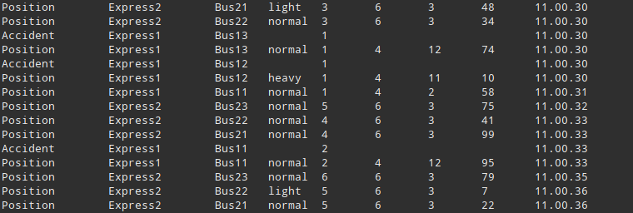

Passenger 1, 2 – Subscriber
The passenger Subscribers (1 and 2) Display messages from the route they are subscribed to, as well as the stop they are subscribed to. Once a bus reaches their stop, they get on the bus and sub to only that bus. Once the bus reaches their “Target” stop, they get off and the executable terminates with a timestamp.

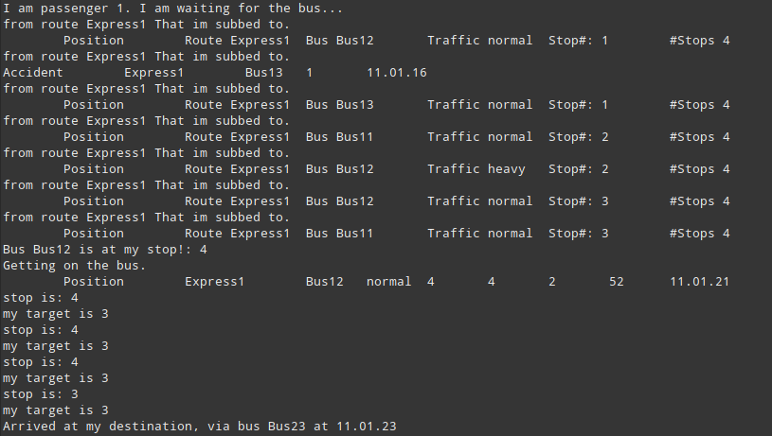
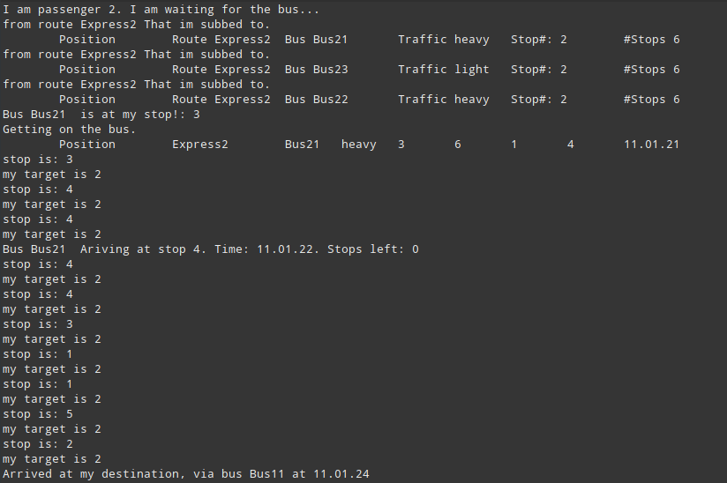

Publisher
The publisher is responsible for publishing all the information to the subscribers. This will add routes and buses, start a thread for each bus, and then begin execution of the simulation. It writes position instances, or accident instances, depending on which happens.
